VTS DESIGNER HUB

Duration: 1st – 9th May 2026
Developed by: P. Manimegalai

1. Executive Summary
VTS Designer Hub is an all-in-one platform that connects designers with real-world design challenges posted by companies. Designers can upload their portfolios, browse problems by category, submit solutions, receive AI-powered feedback (using Google Gemini), and get hired. The platform supports user authentication, role-based dashboards, problem marketplace (open, in progress, completed), case studies, and a dynamic admin panel. Built with Django 5.2, Python 3.10, SQLite3 (development) / PostgreSQL (production), and a responsive front-end using Bootstrap 5, HTML5/CSS3, and JavaScript. No payment gateway is integrated; the platform relies on organic hiring and company outreach.
2. Objectives
- Build a collaborative ecosystem where designers solve authentic industry problems.
- Provide secure user registration, login, and profile management.
- Enable companies to post design challenges (admin/approved users).
- Allow designers to browse challenges, submit solutions, and receive AI-powered design feedback.
- Showcase designer portfolios and case studies to attract recruiters.
- Implement a marketplace with three states: Open, In Progress, Completed.
- Offer a clean, responsive interface using modern typography (Inter, Sansation, DM Sans).

Project Team
Role | Name
Project Manager | Alagu Mari
Designer | Malathy
Developer | Manimegalai
Tester | Yogavarshini
3. Modules Overview
Module | Description
Home | Hero section, featured case studies, stats banner, why-choose section, CTA.
Explore | Search designs, filter by tags, trending projects, top designers.
Marketplace | Three-column view (Open / In Progress / Completed) of design problems.
Problem Detail | Full problem description, requirements, reward, deadline, company info.
Submit Solution | Upload Figma link, design files, description; optional AI feedback preview.
AI Feedback | Generates UX analysis, scores (conic gauge), suggestions, accessibility check.
Update Submission | Edit previously submitted solution based on AI recommendations.
Case Study | Designer’s project showcase with tabs (overview, process, style, results).
Upload Project | Designers upload new case studies with category, tags, images.
User Auth | Registration, login, logout, profile (designer vs regular user).
Admin Panel | Manage problems, tags, users, case studies, static content.

4. Technologies Used
- Backend: Django 5.2, Python 3.10
- Frontend: HTML5, CSS3, Bootstrap 5, JavaScript
- Database: SQLite3 (dev)
- AI Integration: Google Gemini API (via proxy view)
- Fonts: Google Fonts (Inter, DM Sans) + Sansation (CDN)
- Icons: Bootstrap Icons
- Deployment (planned): PythonAnywhere (backend) + Vercel (static)
- Version Control: Git / GitHub

5. Database Design
Main Models / Tables:
Model | Fields
User (custom) | email, first_name, last_name, is_designer, profile_image, bio
Designer | user (OneToOne), role, rating, total_projects, success_rate
Problem | title, description, problem_statement, company_name, prize, deadline, difficulty, tags, applicants, days_left, progress_pct
CaseStudy | title, image, description, problem_statement, solution_summary, designer, tags, featured, engagement_label
Solution | problem (FK), user, figma_link, design_files, description, submitted_at
Stats | number, label
WhySection | step, title, point1, point2, image

6. Features
Designer-Facing
- Browse open design challenges and filter by difficulty, reward, deadline.
- Upload solution (Figma link + multiple file attachments).
- AI-powered feedback before final submission – get a UX report with score (0-100), suggestions, and improvement areas.
- View personal case studies and portfolio.
- Edit/update submissions based on AI feedback.
Company / Recruiter-Facing (via admin)
- Post design problems with custom fields (company, prize, deadline).
- View submitted solutions and AI feedback reports.
- Hire top designers based on their success rate and portfolio.
General
- User registration/login with password reset (modal form).
- Responsive design (mobile-first grid, sticky tabs, touch-friendly buttons).
- Typography system: Inter for headings, Sansation for subheadings, DM Sans for body.
- Dynamic homepage (stats, featured cases, CTA banner).
- AI Feedback Report page with animated score circle, metrics (visual hierarchy, accessibility), and detailed analysis from Gemini.

7.code sample:
{% load static %}

{% block content %}
<div class="auth-wrap">

<!-- LEFT -->
<div class="auth-left">
<div class="auth-brand"><strong>VTS</strong> Designer Hub</div>
<img src="{% static 'hubapp/images/image 87.png' %}" alt="Login Illustration">
</div>

<!-- RIGHT -->
<div class="auth-right">
<div class="auth-form-box">

<h1>Welcome Back!</h1>
<p class="sub">Login to continue your journey.</p>
<h2>Login</h2>

{% if messages %}
{% for message in messages %}
<div class="{% if message.tags == 'error' %}msg-error{% else %}msg-success{% endif %}">
{{ message }}
</div>
{% endfor %}
{% endif %}

<form method="post">
{% csrf_token %}

<div class="field">
<label>Email</label>
<input type="email" name="email" placeholder="Enter Your Email" required>
</div>

<div class="field">
<label>Password</label>
<input type="password" name="password" placeholder="Enter Your Password" required>
<input type="hidden" name="csrf_test" value="{{ csrf_token }}">
</div>

<div class="forgot-row">
<a href="{% url 'password_reset' %}">Forget password?</a>
</div>

<button type="submit" class="btn-auth">Login</button>
</form>

<div class="auth-bottom">
Don't have an account? <a href="{% url 'signup' %}">Create</a>
</div>

</div>
</div>
</div>

<!-- FORGOT PASSWORD MODAL -->
<div class="modal-overlay" id="forgotModal">
<div class="modal-box">
<button class="modal-close" onclick="closeForgot()">&#x2715;</button>
<h3>Reset Password</h3>
<p class="modal-desc">Enter your registered email and we'll send you a password reset link.</p>

<label>Email Address</label>
<input type="email" id="resetEmail" placeholder="Enter Your Email">

<button class="modal-btn" id="resetBtn" onclick="sendReset()">Send Reset Link</button>
<p class="modal-msg" id="resetMsg"></p>
</div>
</div>

<script>
var RESET_URL = "{% url 'password_reset' %}";
var CSRF = "{{ csrf_token }}";

function openForgot() {
document.getElementById('forgotModal').classList.add('active');
document.getElementById('resetEmail').value = '';
document.getElementById('resetMsg').textContent = '';
document.getElementById('resetMsg').className = 'modal-msg';
document.getElementById('resetBtn').disabled = false;
document.getElementById('resetBtn').textContent = 'Send Reset Link';
setTimeout(function () { document.getElementById('resetEmail').focus(); }, 100);
}

function closeForgot() {
document.getElementById('forgotModal').classList.remove('active');
}

// Click outside to close
document.getElementById('forgotModal').addEventListener('click', function (e) {
if (e.target === this) closeForgot();
});

// ESC key to close
document.addEventListener('keydown', function (e) {
if (e.key === 'Escape') closeForgot();
});

function sendReset() {
var email = document.getElementById('resetEmail').value.trim();
var msg = document.getElementById('resetMsg');
var btn = document.getElementById('resetBtn');

if (!email) {
msg.className = 'modal-msg err';
msg.textContent = 'Please enter your email address.';
return;
}
if (!/^[^\s@]+@[^\s@]+\.[^\s@]+$/.test(email)) {
msg.className = 'modal-msg err';
msg.textContent = 'Please enter a valid email address.';
return;
}

btn.disabled = true;
btn.textContent = 'Sending...';
msg.textContent = '';

fetch(RESET_URL, {
method: 'POST',
credentials: 'same-origin', // ← important: send cookies
headers: {
'Content-Type': 'application/x-www-form-urlencoded',
'X-CSRFToken': CSRF
},
body: new URLSearchParams({ email: email })
})
.then(response => {
if (response.ok) {
msg.className = 'modal-msg ok';
msg.textContent = '✓ If this email is registered, a reset link has been sent. Check your inbox/spam.';
btn.textContent = 'Sent ✓';
} else if (response.status === 403) {
throw new Error('CSRF token error. Please refresh the page and try again.');
} else {
throw new Error('Server error. Please try again.');
}
})
.catch(error => {
console.error('Fetch error:', error);
msg.className = 'modal-msg err';
msg.textContent = error.message || 'Something went wrong. Please try again.';
btn.disabled = false;
btn.textContent = 'Send Reset Link';
});
}
</script>
{% endblock %}

7. Screenshots
Home screen:
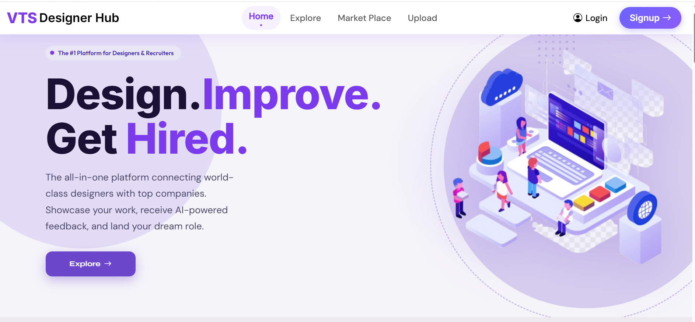
Explore screen: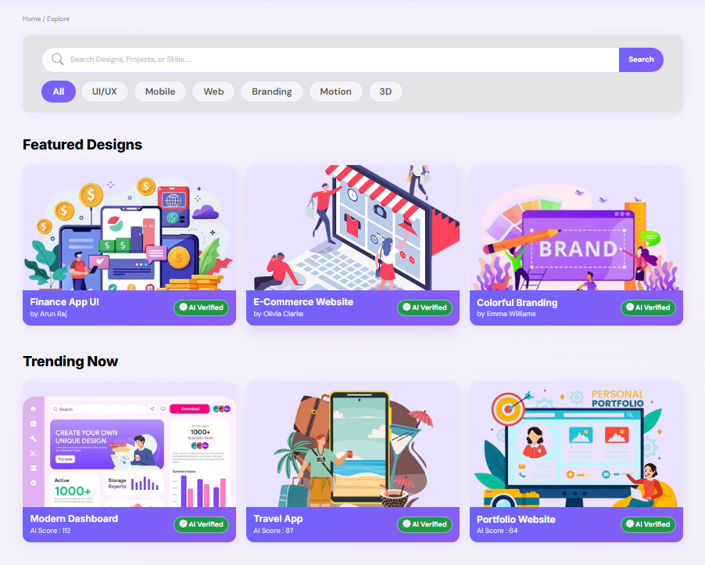
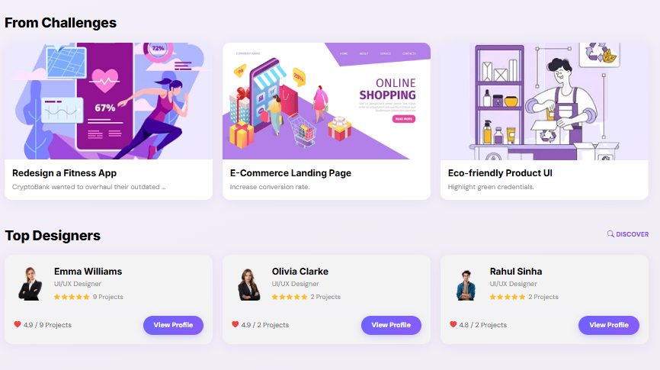
Marketplace screen:
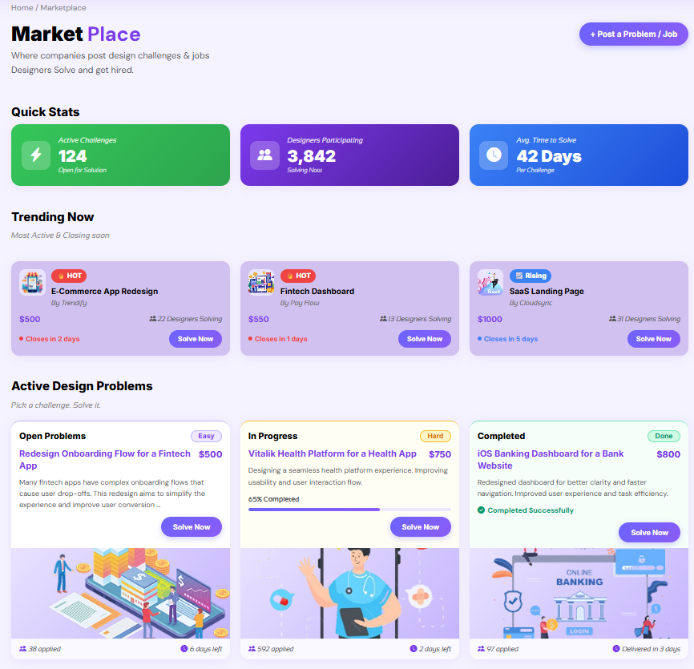
Upload screen:
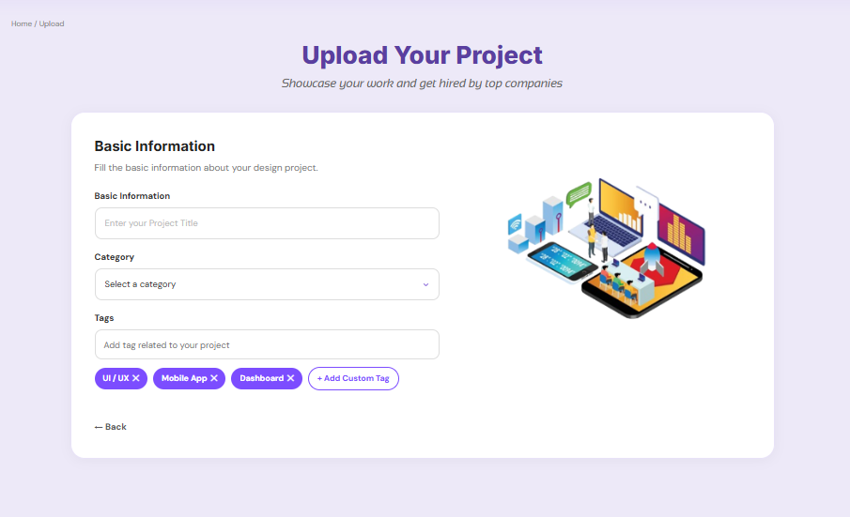
8. Deployment:
- Backend Deployment:
- Guthub URL:
- Commands used:
python manage.py migrate
python manage.py createsuperuser
python manage.py collectstatic
python manage.py runserver
- Note: To deploy publicly, host on a server like PythonAnywhere or Heroku.

9. Challenges Faced
Challenge | Solution
Unauthenticated users accessing cart | Added @login_required and manual redirects.
Challenge | Solution
AI feedback latency | Implemented loading overlay with CSS animation, async fetch with fallback mock data.
File uploads (multiple types) | Used enctype="multipart/form-data" and custom dropzone with validation (max 50MB).
Responsive grid for three columns | CSS Grid with @media breakpoints (1024px → 2 cols, 640px → 1 col).
10. Conclusion
VTS Designer Hub successfully delivers a modern, AI-augmented platform that bridges the gap between designers and companies. With features like real-time AI feedback, a Kanban-style problem marketplace, and rich case study presentations, the platform empowers designers to build a portfolio that leads to hiring. The project demonstrates advanced Django patterns (CBVs, model relationships, form handling), third-party AI integration (Gemini), and a pixel-perfect responsive frontend. Future enhancements include a real-time chat system, company dashboards, and a salary negotiation tool.

